**TEMPERATURE AND HUMIDITY DETECTION**

_____________________________________________

PYTHON CODE:

print("Enter the temperature")

temperature =int(input())

print("Enter the humidity")

humidity=int(input())

if temperature>=37:

if humidity>=50:

print("The Temperature is greater than the normal temperature")

print("Humidity also High")

print("Buzzer ON")

else:

print("Temperature is Hot and Normal Humidity")

print("Buzzer ON")

else:

print("Temperature is LOW and Normal Humidity")

print("NO Buzzer")

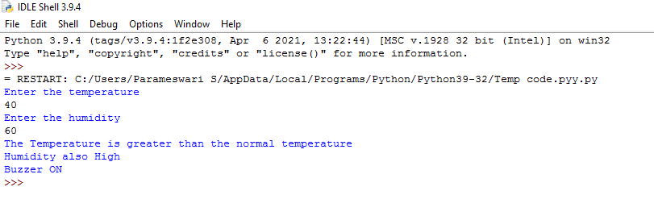OUTPUT SCREEN:

**S.PARAMESH**

961819106041

Ponjesly College of Engineering